**Assignment Lab1: Company Database**

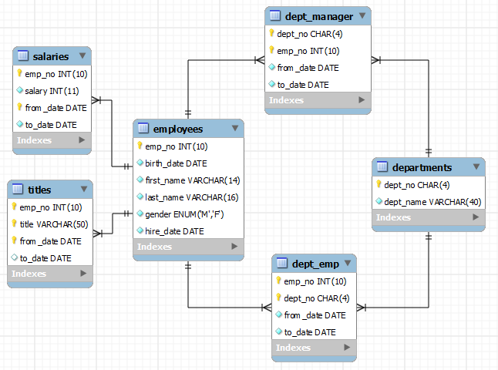There are 6 tables as follows:

1. Write a CREATE TABLE statement for all the *above* tables. Choose data types appropriate for the DBMS used in your course (mysql).
2. The column ‘*to_date*’ in all table supports NULL values. Define NOT NULL constraints for all other columns. Because of MySQL syntax limitations for NOT NULL constraints (column level with no constraint name and no CONSTRAINT keyword), you should define column level(inline) NOT NULL constraints.
3. All other columns are required (not null).
4. The columns preceded by yellow key implies primary key columns.
5. Identify the foreign key(s) among the tables. For each relationship, identify the parent table and the child table.
6. Extend your CREATE TABLE statement with referential integrity constraints.
7. Extend your CREATE TABLE statement for the *Departments* table with a unique constraint for *dept_name*. Use an external named constraint clause for the unique constraint.
8. Define a CHECK constraint to restrict the *dept_name* column to have a value of “Computer Science”, “Electronics & Communication”, “Computer & Communication” or “Mechanical & Mechatronics”. You can use the IN operator in this constraint. In MySQL, the syntax does not allow the CONSTRAINT keyword and a constraint name for CHECK constraints. You should use the CHECK keyword followed by the condition enclosed in parentheses.
9. Define a CHECK constraints to ensure that the *salary* is greater than 0.
10. Define a CHECK constraint to ensure that hire_date > birth_date.